MINISTRY OF HEALTH
1448 NICOSIA

Health Monitoring Unit

Summary Report on fatal injuries Analysis for fatal injuries in children between 0-19 years
(Data 2004-2015)

---------------------------------------------------------------------------------------------------------
Prepared by: Maria Athanasiadou

Death Registry
Health Monitoring Unit
Ministry of Health
1 Prodromou and 17 Chilonos Str
1448 Nicosia
Cyprus

Tel.: +357 22 605389
Fax: +357 22 605527
Website: http://www.moh.gov.cy

November 2016

For this report

This report is based on mortality data from 2004-2015. It is an up-to –date summary of the main results of fatal injuries in Cyprus referring to children between 0-19 years as well for all age groups.

Data for fatal injuries (2004-2015) are based on death certificates, collected and coded by the Health Monitoring Unit.

The total number of fatal injuries includes deaths for both residents and non-residents occurred in Cyprus as well as deaths of permanent residents occurred abroad.

Analysis for all fatal injuries in children (0-19 years) and all age groups, 2004-2015
Table 1: Fatal injuries by causes of death, all ages, 2004-2015

Year | Other unintentional injuries | Road traffic injuries | Self-inflicted | Falls | Drowning | Interpersonal violence | Poisoning | Other injuries | Fires | Total
2004 | 116  (36,4%) | 128 (40,1%) | 7  (2,2%) | 18 (5,6%) | 20  (6,3%) | 10  (3,1%) | 3  (0,9%) | 12 (3,8%) | 5 (1,6%) | 319 (100%)
2005 | 220  (53,7%) | 118 (28,8%) | 17 (4,1%) | 15 (3,7%) | 13  (3,2%) | 14  (3,4%) | 3  (0,7%) | 8  (2%) | 2 (0,5%) | 410 (100%)
2006 | 114  (38,8%) | 89  (30,3%) | 19 (6,5%) | 25 (8,5%) | 16  (5,4%) | 14  (4,8%) | 11  (3,7%) | 2  (0,7%) | 4 (1,4%) | 294 (100%)
2007 | 101  (30,6%) | 106 (32,1%) | 19 (5,8%) | 29 (8,8%) | 32  (9,7%) | 11  (3,3%) | 16  (4,8%) | 10  (3%) | 6 (1,8%) | 330 (100%)
2008 | 87  (27,7%) | 97  (30,9%) | 42 (13,4%) | 24 (7,6%) | 34 (10,8%) | 9  (2,9%) | 12  (3,8%) | 3  (1%) | 6 (1,9%) | 314 (100%)
2009 | 96  (30,7%) | 93  (29,7%) | 33 (10,5%) | 31 (9,9%) | 21  (6,7%) | 17  (5,4%) | 13  (4,2%) | 6  (1,9%) | 3  (1%) | 313 (100%)
2010 | 97  (33,1%) | 80  (27,3%) | 38  (13%) | 23 (7,8%) | 27  (9,2%) | 4  (1,4%) | 10  (3,4%) | 11 (3,8%) | 3  (1%) | 293 (100%)
2011 | 73  (26,4%) | 83  (30%) | 31 (11,2%) | 28 (10,1%) | 18  (6,5%) | 23  (8,3%) | 16  (5,8%) | 3  (1,1%) | 2 (0,7%) | 277 (100%)
2012 | 109  (37,2%) | 66  (22,5%) | 38  (13%) | 27 (9,2%) | 18  (6,1%) | 22  (7,5%) | 9  (3,1%) | 1  (0,3%) | 3  (1%) | 293 (100%)
2013 | 120  (41,4%) | 54  (18,6%) | 45 (15,5%) | 32 (11%) | 15  (5,2%) | 12  (4,1%) | 8  (2,8%) | 2  (0,7%) | 2 (0,7%) | 290 (100%)
2014 | 116  (38,7%) | 56  (18,7%) | 44 (14,7%) | 35 (11,7%) | 28  (9,3%) | 9  (3%) | 10  (3,3%) | 0  (0%) | 2 (0,7%) | 300 (100%)
2015 | 107  (37,5%) | 74  (26%) | 40  (14%) | 22 (7,7%) | 12  (4,2%) | 13  (4,6%) | 12  (4,2%) | 0  (0%) | 5 (1,8%) | 285 (100%)
2004-2015 | 1356  (36,5%) | 1044 (28,1%) | 373 (10%) | 309 (8,3%) | 254 (6,8%) | 158  (4,2%) | 123  (3,3%) | 58 (1,6%) | 43 (1,2%) | 3718 (100%)

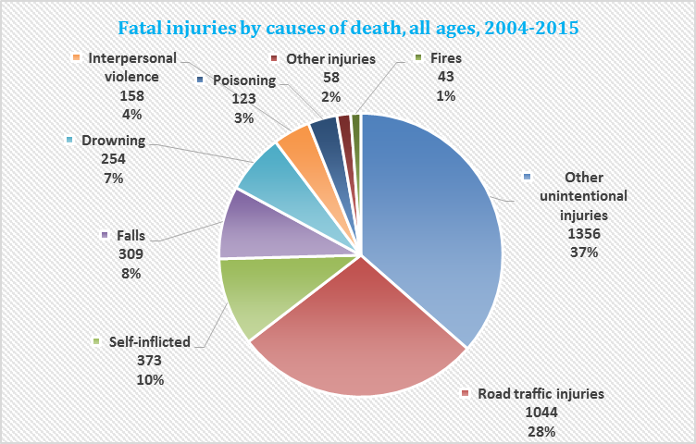

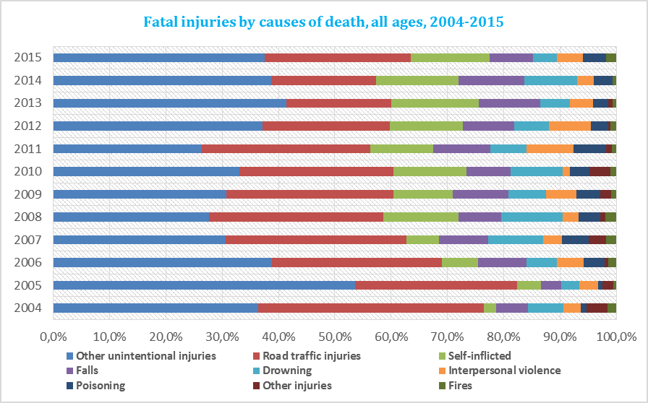

Table 2: Injury death rate (per 100 000 persons) by age groups and sex, 2015

Age group (85+) | Injury death rate (per 100 000) Males | Injury death rate (per 100 000) Females | Total
0-4 | 0,0 | 8,7 | 4,2
5-9 | 0,0 | 0,0 | 0,0
10-14 | 0,0 | 0,0 | 0,0
15-19 | 30,7 | 3,9 | 17,4
20-24 | 55,1 | 6,1 | 30,6
25-29 | 25,4 | 8,4 | 16,8
30-34 | 33,9 | 5,7 | 19,2
35-39 | 34,5 | 12,0 | 22,5
40-44 | 27,4 | 0,0 | 12,7
45-49 | 11,7 | 21,1 | 16,6
50-54 | 37,2 | 3,5 | 19,9
55-59 | 39,1 | 7,7 | 23,3
60-64 | 48,7 | 25,7 | 37,0
65-69 | 52,3 | 31,3 | 41,5
70-74 | 53,5 | 48,0 | 50,6
75-79 | 120,9 | 104,1 | 111,8
80-84 | 115,4 | 106,8 | 110,4
85+ | 781,9 | 357,5 | 522,1
Total | 42,2 | 21,6 | 31,6

Table 3: Relative injury mortality (injury deaths in % of all causes of death) by age groups and sex, 2015
Age group (85+) | Relative injury mortality  Males | Relative injury mortality  Females | Total
0-4 | 0,0% | 11,1% | 6,7%
5-9 | 0,0% | 0,0% | 0,0%
10-14 | 0,0% | 0,0% | 0,0%
15-19 | 88,9% | 20,0% | 64,3%
20-24 | 72,0% | 50,0% | 69,0%
25-29 | 64,3% | 75,0% | 66,7%
30-34 | 73,3% | 28,6% | 59,1%
35-39 | 33,3% | 20,0% | 28,0%
40-44 | 17,5% | 0,0% | 9,7%
45-49 | 6,8% | 23,1% | 12,9%
50-54 | 11,1% | 2,0% | 7,9%
55-59 | 8,5% | 3,0% | 6,5%
60-64 | 5,3% | 6,3% | 5,6%
65-69 | 4,0% | 4,3% | 4,1%
70-74 | 2,3% | 4,0% | 2,9%
75-79 | 3,4% | 4,1% | 3,7%
80-84 | 1,6% | 1,9% | 1,8%
85+ | 3,8% | 2,1% | 2,8%
Total | 5,7% | 3,3% | 4,6%

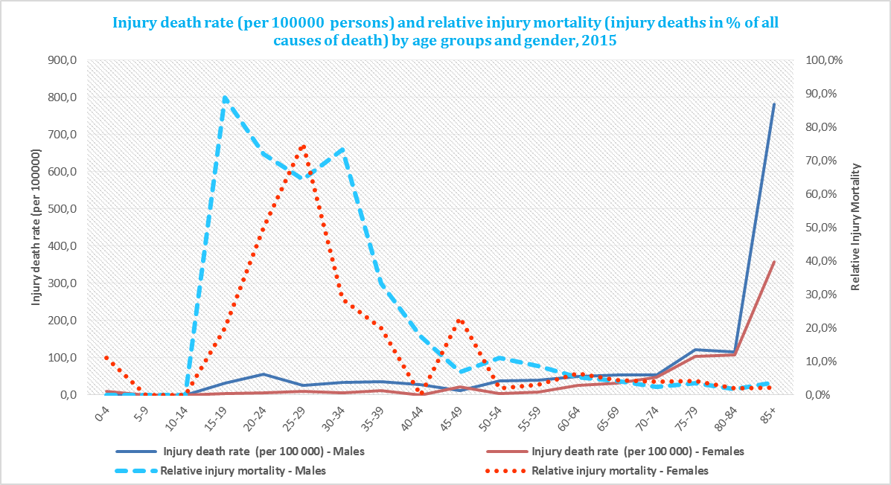

Table 4: Cause of death of children 0-19 years, 2004-2015
Rank order | Cause | ICD10 code | N | % of the total number of deaths for children 0-19 years
1 | External causes of mortality | V01-Y98 | 236 | 30%
2 | Malignant neoplasms | Q00-Q99 | 77 | 10%
3 | Congenital malformations, deformations and chromosomal abnormalities | C00-C97 | 62 | 8%
4 | Diseases of the nervous System and sense organs | G00-H95 | 40 | 5%
5 | Diseases if the respiratory system | J00-J99 | 13 | 2%
6 | Other causes of death |  | 370 | 46%
All causes of death |  |  | 798 | 100%

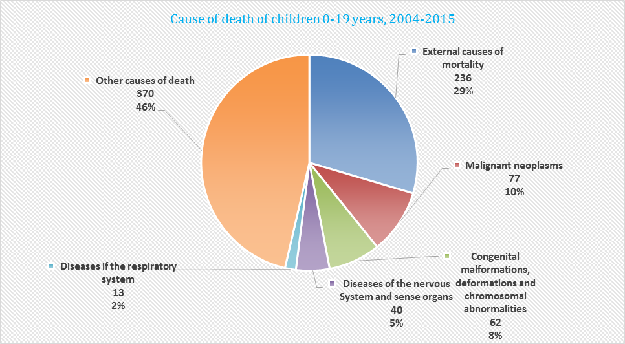

Table 5: Causes of fatal injuries in children between 0-19 years, 2004-2015
Cause of death | ICD-10 | N | %
Fires | (X00-X09) | 1 | 0,4%
Poisoning | (X40-X49) | 3 | 1,3%
Falls | (W00-W19) | 6 | 2,5%
Interpersonal violence | (X85-Y09, X871) | 12 | 5,1%
Self-inflicted | (X60-X84,Y870) | 16 | 6,8%
Drowning | (W65-W74) | 20 | 8,5%
Other injuries | (V90-V98, W20-W64, W75-W99, X10-X39,  X50-X59, Y40-Y86, Y88, Y89, Y36, Y35) | 42 | 17,8%
Road traffic injuries | (V01-V89, V99, Y850) | 136 | 57,6%
Total number of fatal injuries |  | 236 | 100,0%

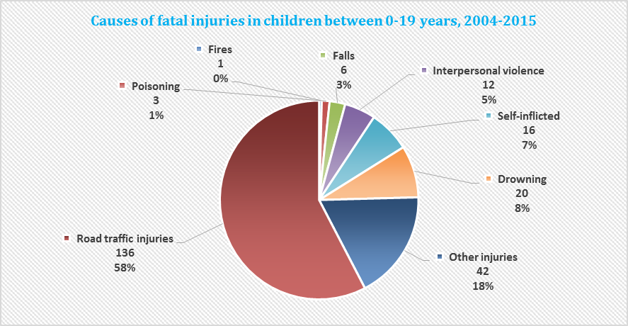

Table 6: Road fatalities by type of road user in children between 0-19 years, 2004-2015

Type of road user | 0-4 | 5-9 | 10-14 | 15-19 | Total | %
Motor cycle |  |  | 4 | 40 | 44 | 32,4%
Other road transport | 3 | 2 | 3 | 63 | 71 | 52,2%
Pedal cycle |  |  | 1 | 3 | 4 | 2,9%
Pedestrian | 6 | 3 |  | 8 | 17 | 12,5%
Total | 9 | 5 | 8 | 114 | 136 | 100,0%

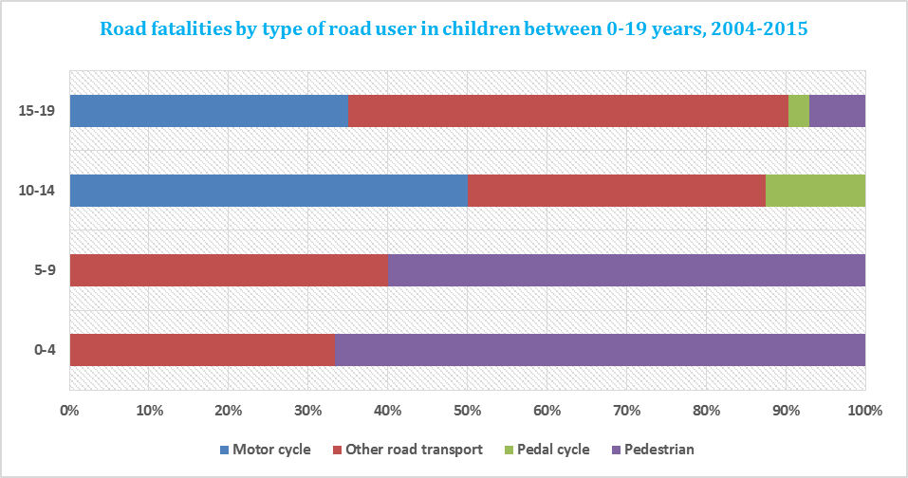

Table 7: Fatal sports injuries by type of sports (excluding swimming) and age group (all ages), 2004-2015

Type of sports | 00-14 | 15-24 | 25-59 | 60+ | Total | %
Aero (non-motored) sports |  |  | 1 | 1 | 2 | 4,9%
Bicycling non-traffic | 1 | 6 | 15 | 5 | 27 | 65,9%
Boating sports |  | 3 | 8 | 1 | 12 | 29,3%
Total | 1 | 9 | 24 | 7 | 41 | 100,0%

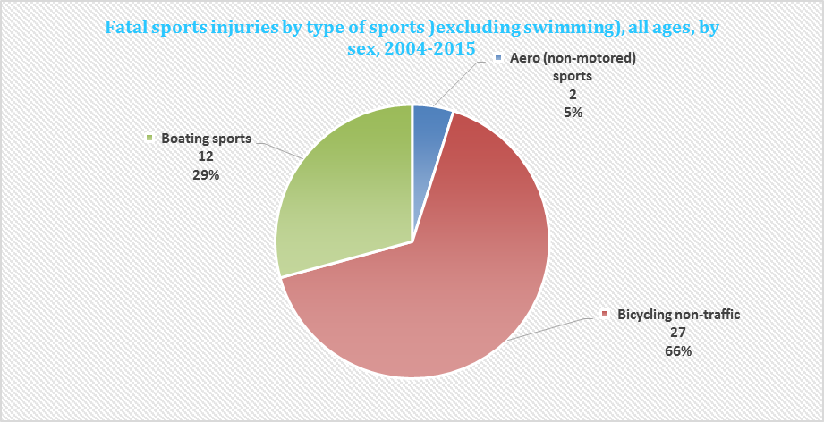
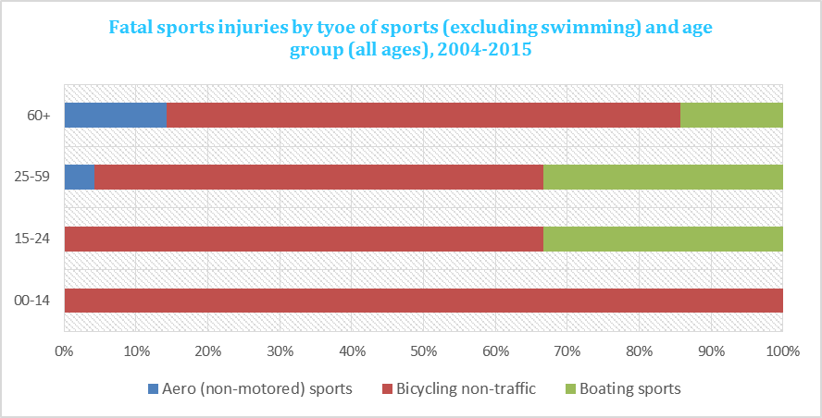

Note: Fatal sports injuries by type of sports (excluding swimming) for children 0-19 years in the period 2004-2015 were equal to four (4) deaths due to non-traffic bicycling.

Table 8: Fatalities through interpersonal violence by means of assault, all ages, 2004-2015

Means of assault | 00-14 | 15-24 | 25-59 | 60+ | Total | %
Blunt object |  |  | 7 | 1 | 8 | 5,1%
Bodily force |  | 1 | 7 |  | 8 | 5,1%
Firearm discharge | 1 | 7 | 43 | 11 | 62 | 39,2%
Hanging, strangulation, suffocation | 2 | 2 | 6 | 2 | 12 | 7,6%
Maltreatment, neglect | 1 | 3 | 10 | 1 | 15 | 9,5%
Other or unknown means |  | 3 | 13 | 1 | 17 | 10,8%
Sharp object |  | 9 | 24 | 3 | 36 | 22,8%
Total | 4 | 25 | 110 | 19 | 158 | 100,0%

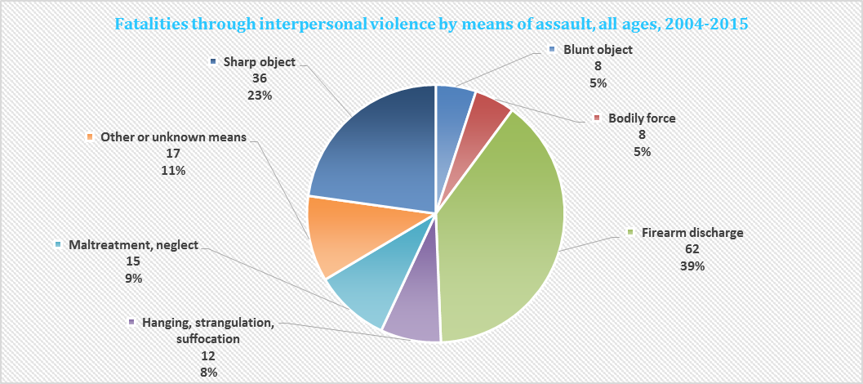

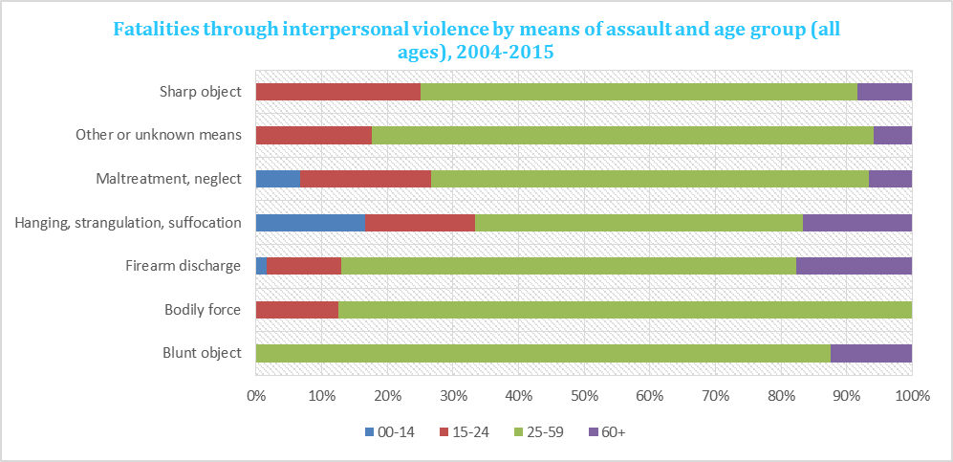

Table 9: Fatalities through interpersonal violence by means of assault, by age group and sex, 2004-2015

Age group | Males | Females | Total
0-4 | 1 | 2 | 3
5-9 |  | 1 | 1
10-14
15-19 | 8 |  | 8
20-24 | 13 | 4 | 17
25-29 | 9 | 4 | 13
30-34 | 21 | 5 | 26
35-39 | 11 | 6 | 17
40-44 | 12 | 5 | 17
45-49 | 12 | 4 | 16
50-54 | 12 |  | 12
55-59 | 7 | 2 | 9
60-64 | 3 |  | 3
65-69 | 6 | 1 | 7
70-74 | 3 | 1 | 4
75-79 | 2 | 2 | 4
80-84 |  | 1 | 1
85+
Total | 120 | 38 | 158

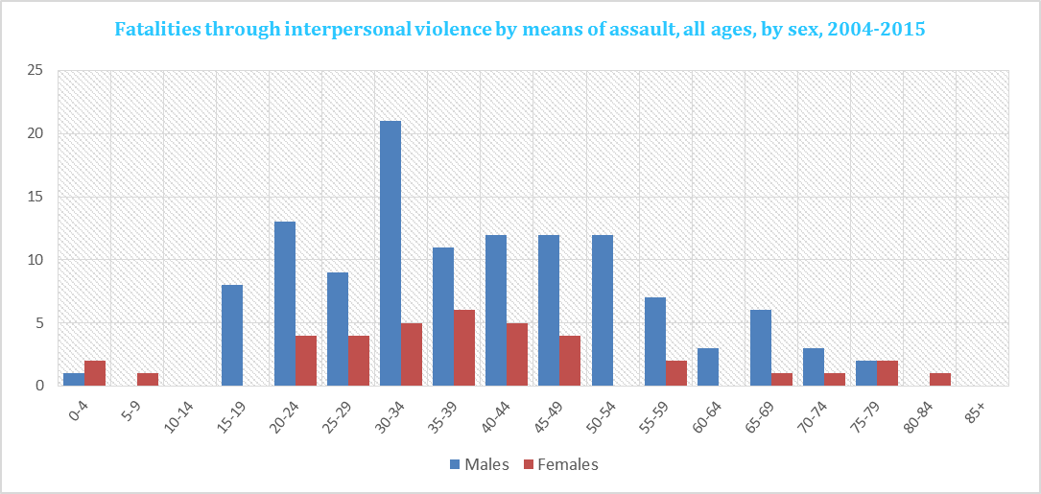

Table 10: Fatalities through interpersonal violence by means of assault in children (0-19 years), 2004-2015

Means of assault | 0-4 | 5-9 | 10-14 | 15-19 | Total | %
Bodily force |  |  |  | 1 | 1 | 8,3%
Firearm discharge |  | 1 |  |  | 1 | 8,3%
Hanging, strangulation, suffocation | 2 |  |  |  | 2 | 16,7%
Maltreatment, neglect | 1 |  |  | 3 | 4 | 33,3%
Other or unknown means |  |  |  | 2 | 2 | 16,7%
Sharp object |  |  |  | 2 | 2 | 16,7%
Total | 3 | 1 |  | 8 | 12 | 100,0%

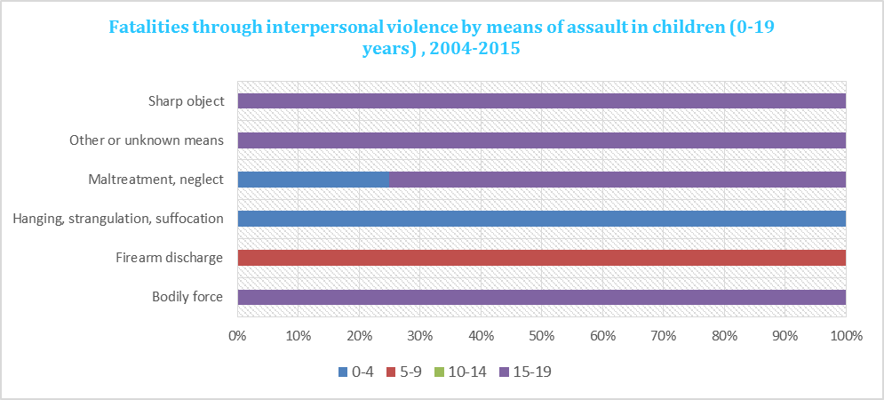

Table 11: Suicides by means of self-harm and age group (all years), 2004-2015
Means of self-harm | 00-14 | 15-24 | 25-59 | 60+ | Total | %
Drowning and submersion |  |  | 3 | 1 | 4 | 1,1%
Firearm discharge |  | 19 | 44 | 18 | 81 | 21,7%
Hanging strangulation and suffocation |  | 23 | 93 | 15 | 131 | 35,1%
Intentional self-poisoning |  | 1 | 46 | 15 | 62 | 16,6%
Jumping from a high place |  | 7 | 45 | 18 | 70 | 18,8%
Jumping or lying before moving object |  |  | 1 |  | 1 | 0,3%
Other and unknown means |  | 1 | 12 | 2 | 15 | 4,0%
Sharp object |  | 1 | 5 | 3 | 9 | 2,4%
Total |  | 52 | 249 | 72 | 373 | 100,0%

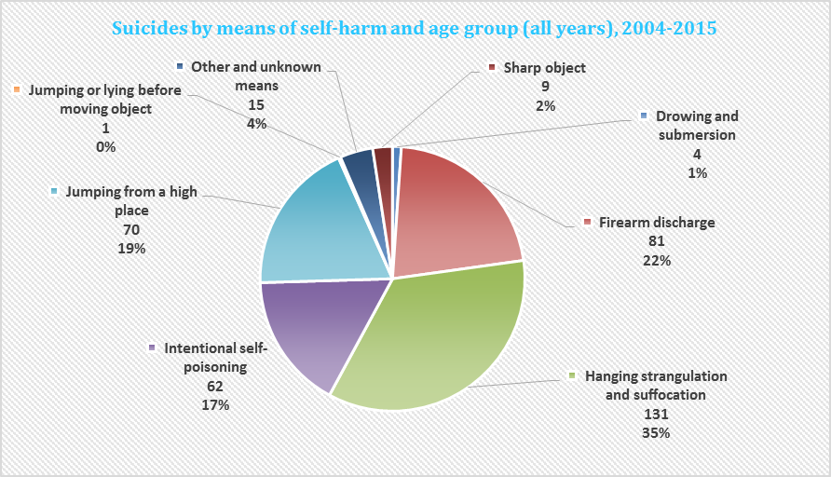
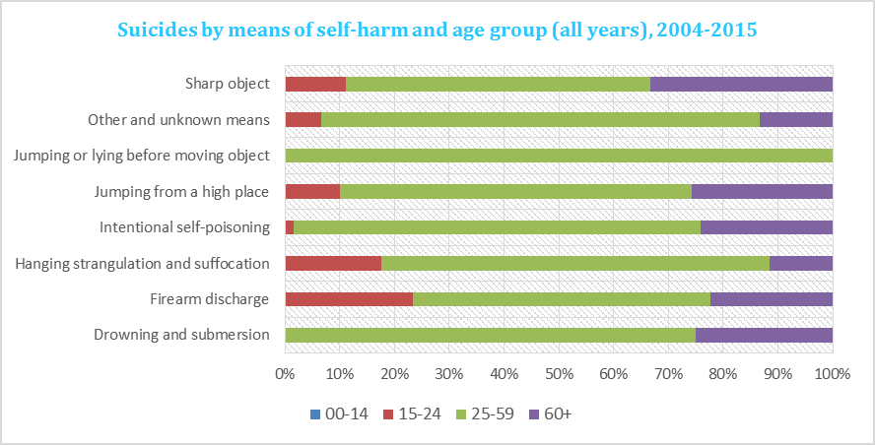

Table 12: Suicides by means of self-harm in children (0-19 years), 2004-2015

Means of self-harm | 0-4 | 5-9 | 10-14 | 15-19 | Total | %
Firearm discharge |  |  |  | 9 | 9 | 56,3%
Hanging strangulation and suffocation |  |  |  | 4 | 4 | 25,0%
Jumping from a high place |  |  |  | 3 | 3 | 18,8%
Total |  |  |  | 16 | 16 | 100,0%

